DATE: 16-06-2026

EXPERIMRNT-21:
Write a Pandas program to swap the cases of a specified character column in each Data Frame.

AIM: To write a Pandas program to swap the case of characters in a specified column of a DataFrame using the str.swapcase() function.

ALGORITHAM:
- Import the Pandas library.
- Create a DataFrame containing a column named Name with the given names.
- Display the original DataFrame.
- Apply the str.swapcase() method to the Name column.
- Store the modified values back into the Name column.
- Display the DataFrame after swapping the case of the characters.
- End the program.
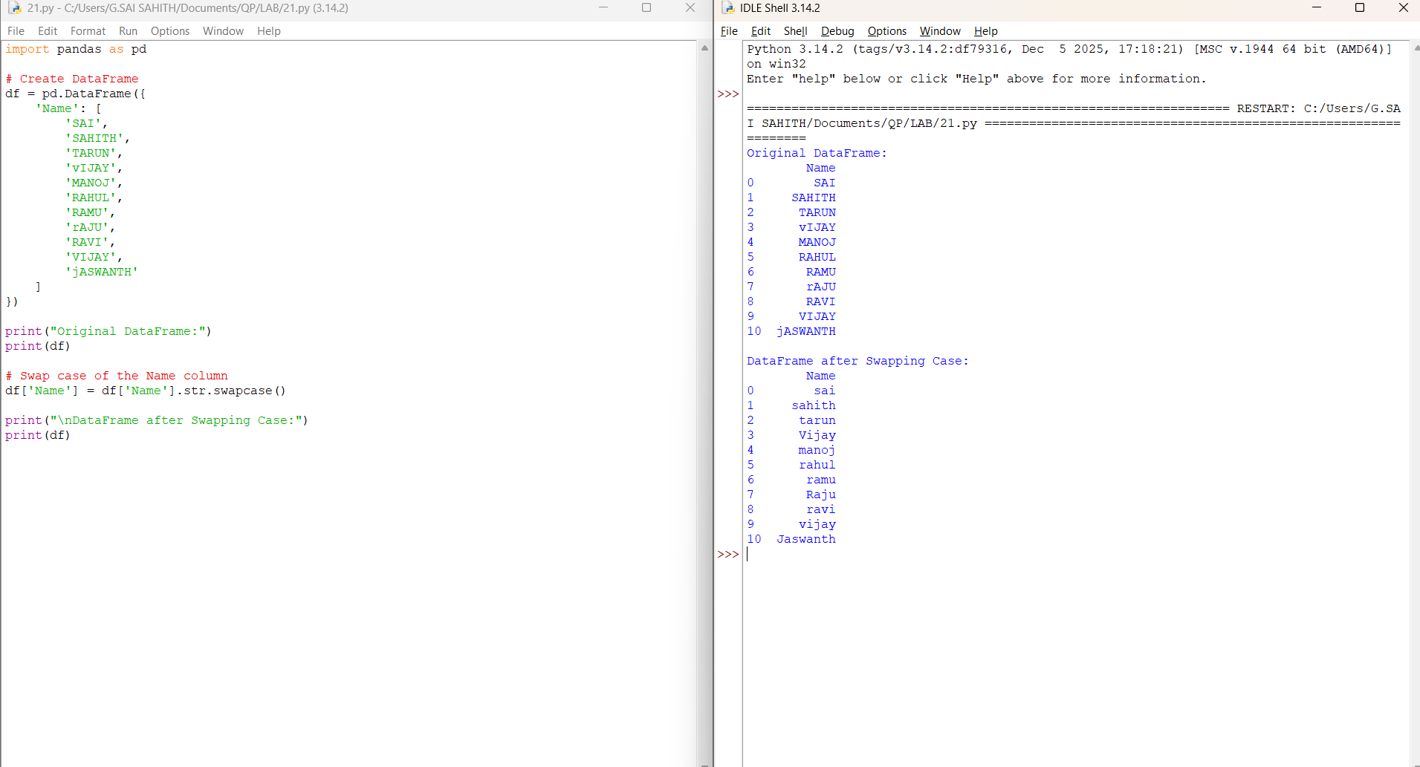

Result :
The cases of all characters in the Name column are successfully swapped using the Pandas str.swapcase() method.
DATE: 16-06-2026

EXPERIMRNT-22:
Write a Python program to draw a line with suitable label in the
x axis, y axis and a title.

AIM: To write a Python program using Matplotlib to draw a line graph with labels for the x-axis, y-axis, and a title.

ALGORITHAM:
- Import the matplotlib.pyplot module.
- Create two lists containing x-axis and y-axis values.
- Use the plot() function to draw the line.
- Add a label to the x-axis using xlabel().
- Add a label to the y-axis using ylabel().
- Add a title using title().
- Display the graph using show().
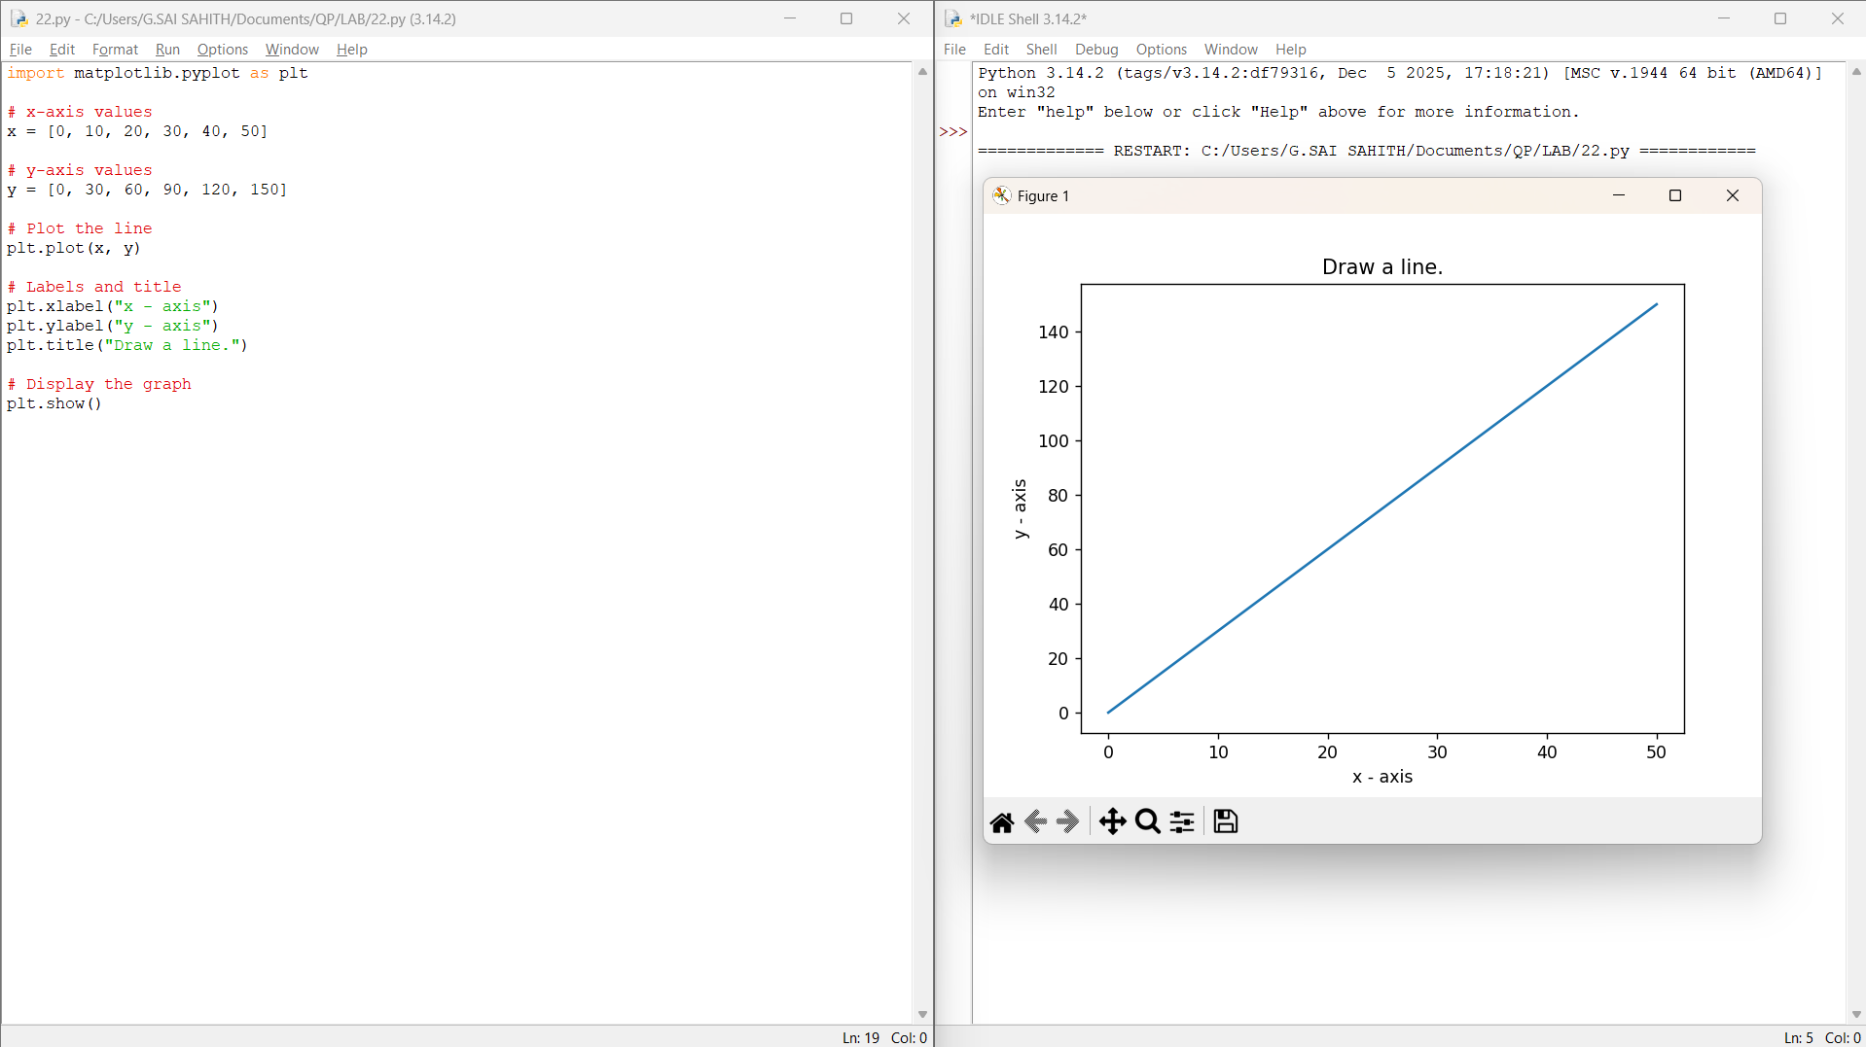

Result :
Thus, a line graph with suitable labels for the x-axis, y-axis, and a title was successfully drawn using Matplotlib.

DATE: 16-06-2026

EXPERIMRNT-23:
Write a Python program to draw a line using given axis values taken from a text file, with suitable label in the x-axis, y-axis and a title.

AIM: To write a Python program that reads x-axis and y-axis values from a text file and draws a line graph with suitable labels and a title using Matplotlib.

ALGORITHAM :
- Create a text file named test.txt containing x and y values.
- Import the matplotlib.pyplot module.
- Open the text file and read the data.
- Store the first column values in the x-axis list and the second column values in the y-axis list.
- Use the plot() function to draw the line graph.
- Add labels to the x-axis and y-axis.
- Add a title to the graph.
- Display the graph using show().
- End the program.
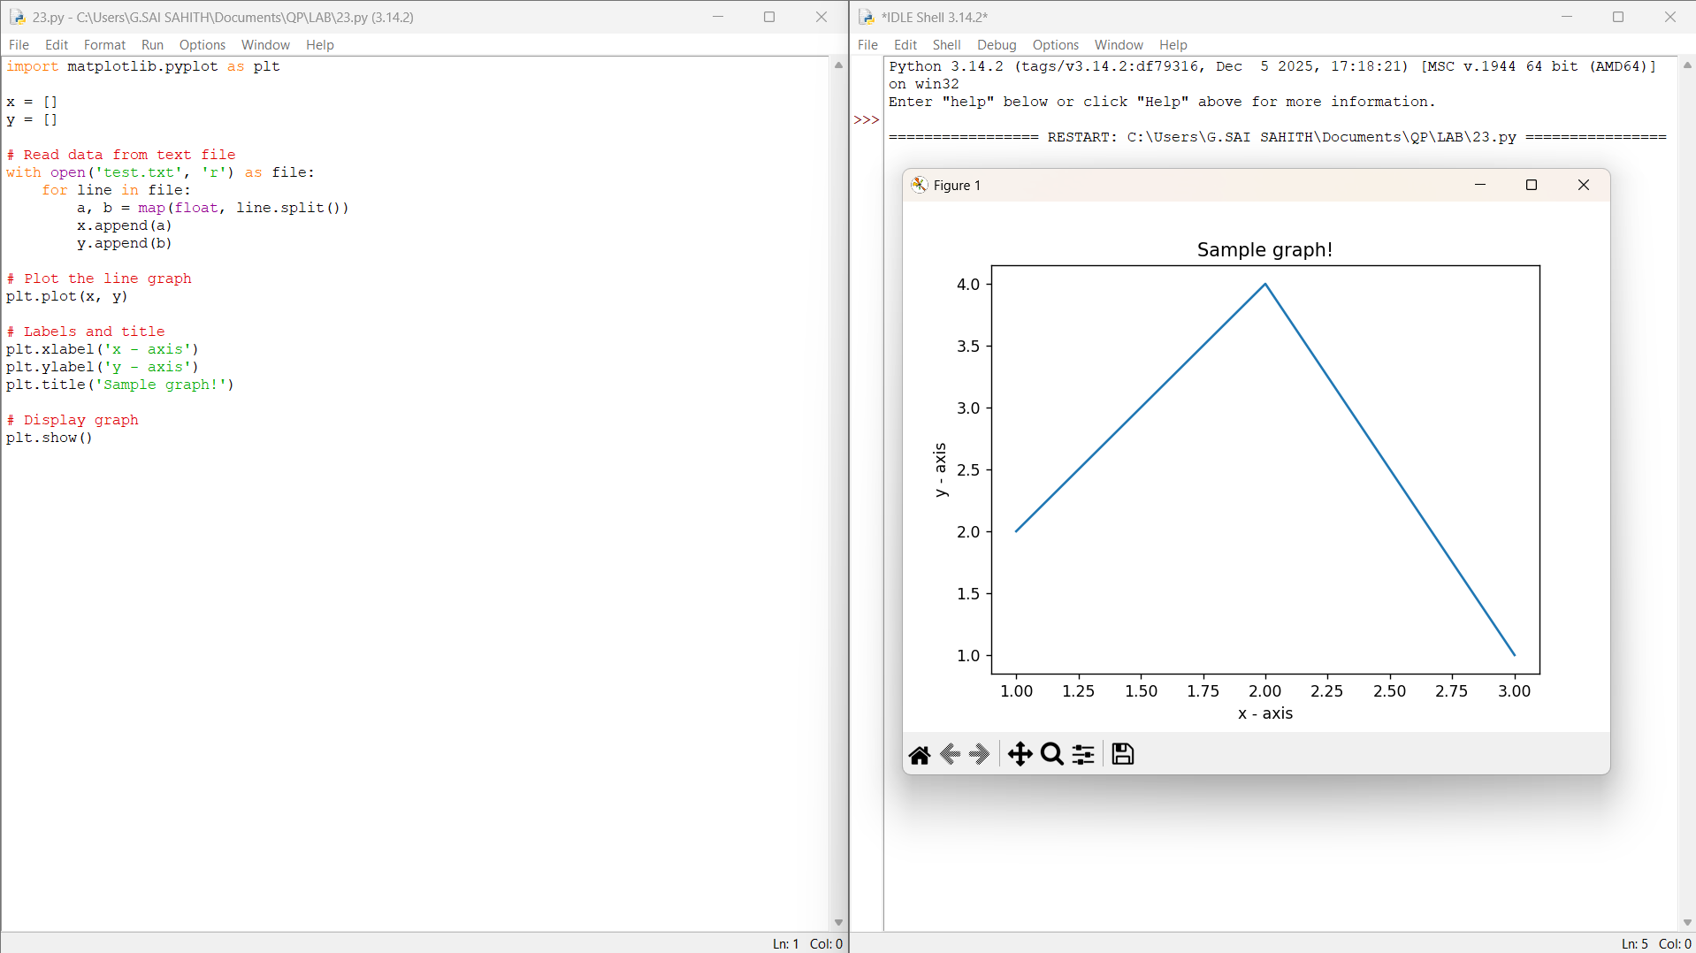
Result :
Thus, the line graph was successfully plotted using the values (1,2), (2,4), and (3,1) with suitable labels and title.
DATE: 17-06-2026

EXPERIMRNT-24:
24.Write a Python program to draw line charts of the financial data of Alphabetic. between October 3, 2016, 2016,ctober 7, 2016.

AIM: To write a Python program to plot the financial data of Alphabet Inc. from a CSV file and draw line charts for Open, High, Low, and Close prices using Matplotlib.

ALGORITHAM:
- Import the required libraries (pandas and matplotlib.pyplot).
- Read the financial data from the CSV file (fdata.csv).
- Extract the Date, Open, High, Low, and Close columns.
- Plot line charts for Open, High, Low, and Close prices against Date.
- Add labels to the x-axis and y-axis.
- Add a suitable title.
- Display the legend.
- Show the graph.
- End the program.

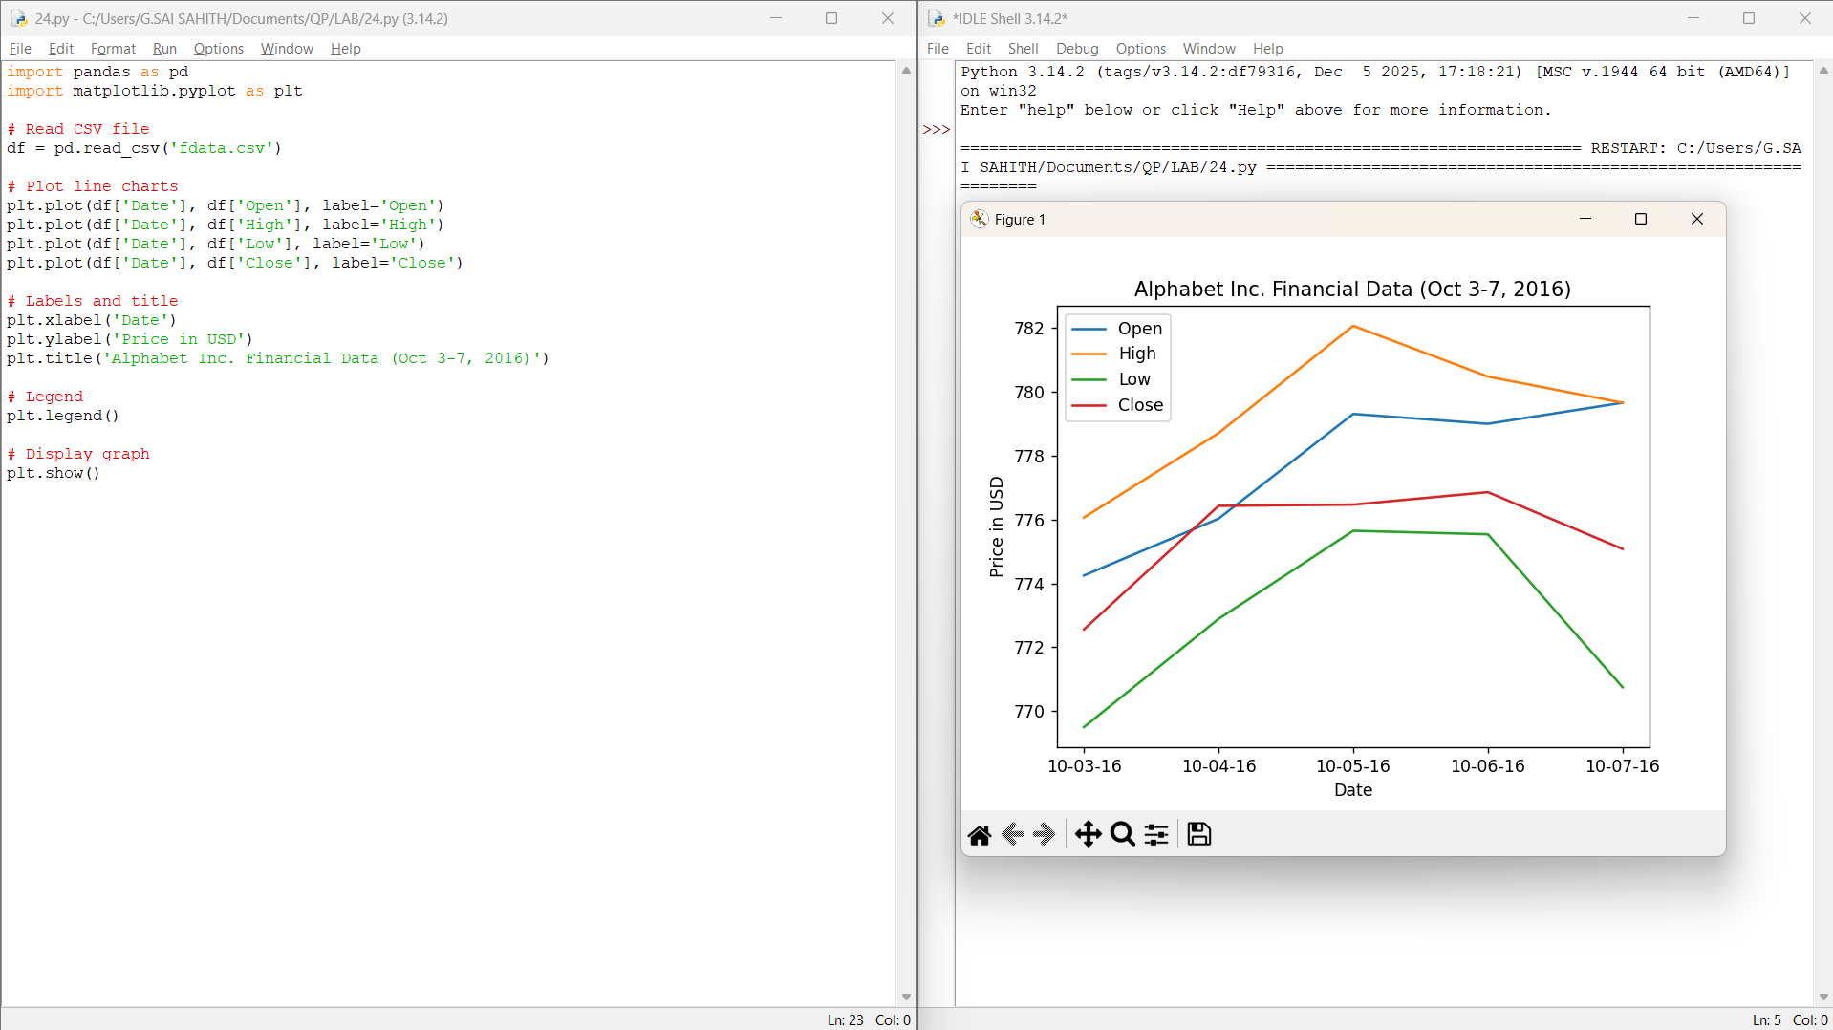
Result :
Thus, the line charts representing the Open, High, Low, and Close stock prices of Alphabet Inc. from October 3, 2016 to October 7, 2016, were successfully plotted .
DATE: 17-06-2026

EXPERIMRNT-25:

AIM: To write a Python program to plot two or more lines with different colours, line widths, and legends using Matplotlib.

ALGORITHAM:
- Import the matplotlib.pyplot module.
- Create lists for x-axis and y-axis values.
- Plot the first line using a specific colour and line width.
- Plot the second line using a different colour and line width.
- Add labels for the x-axis and y-axis.
- Add a suitable title to the graph.
- Display the legend.
- Show the graph using show().
- End the program.

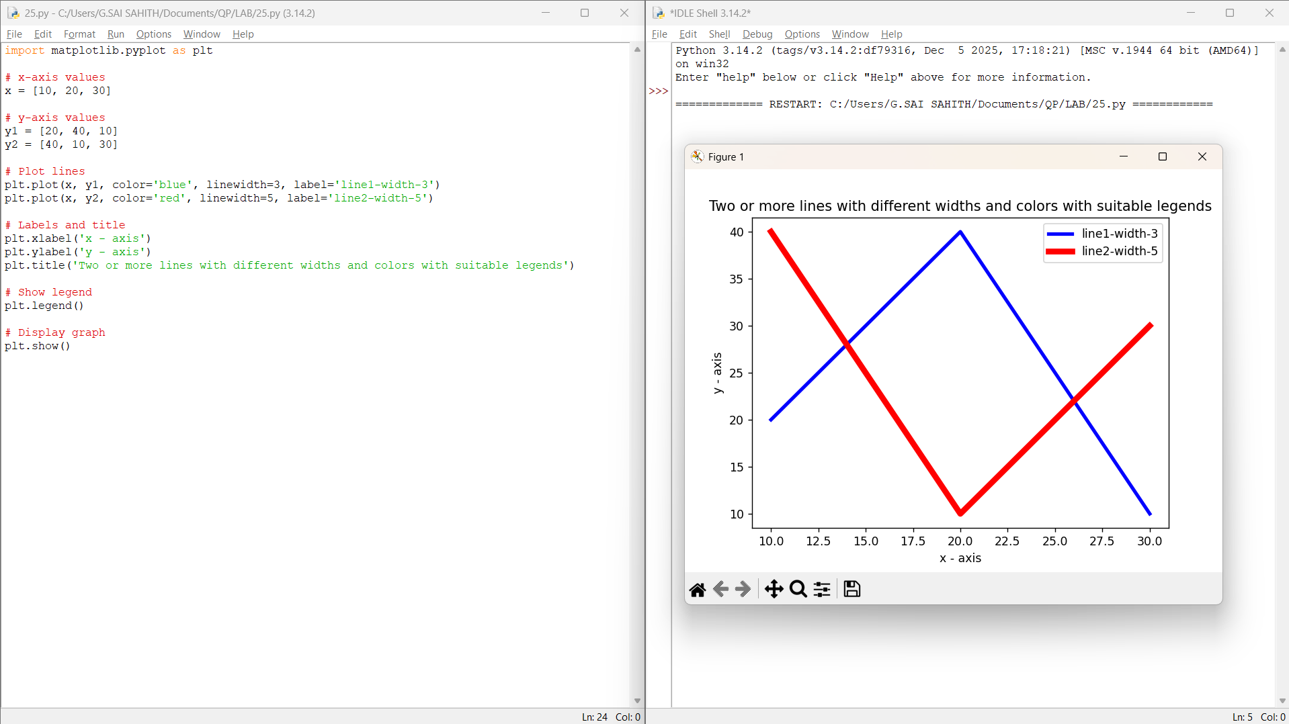

Result :
Thus, the Python program to plot two or more lines with different colours, widths, and legends was executed successfully using Matplotlib.
DATE: 17-06-2026

EXPERIMRNT-26:

AIM: To write a Python program to create multiple plots using Matplotlib.

ALGORITHAM:
- Import the matplotlib.pyplot module.
- Create a figure using figure().
- Add multiple subplots using add_subplot().
- Plot different graphs in each subplot.
- Add titles to the subplots.
- Adjust the layout using tight_layout().
- Display all plots using show().
- End the program.

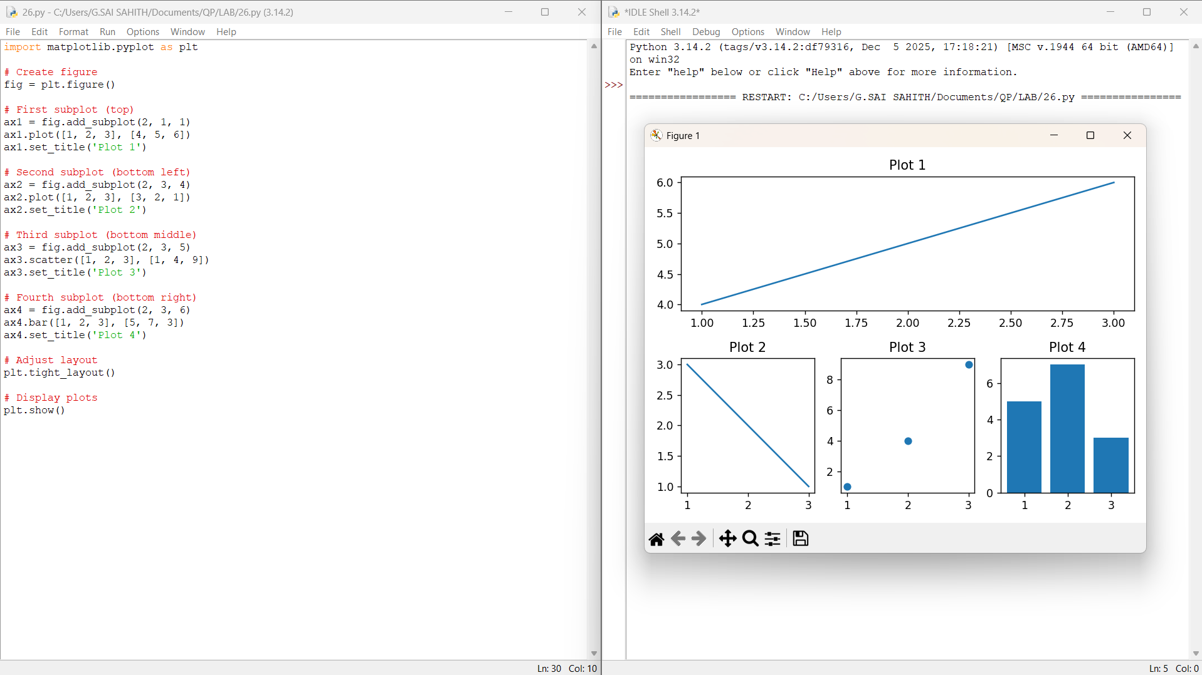

Result :
Thus, the Python program to create multiple plots using Matplotlib was executed successfully.

DATE: 18-06-2026

EXPERIMRNT-27:

AIM: To write a Python program to display a bar chart representing the popularity of various programming languages using Matplotlib.

ALGORITHAM:
- Import the matplotlib.pyplot module.
- Create a list of programming languages.
- Create a list of popularity values corresponding to each language.
- Use the bar() function to create the bar chart.
- Add labels to the x-axis and y-axis.
- Add a suitable title to the chart.
- Display the chart using show().
- End the program.

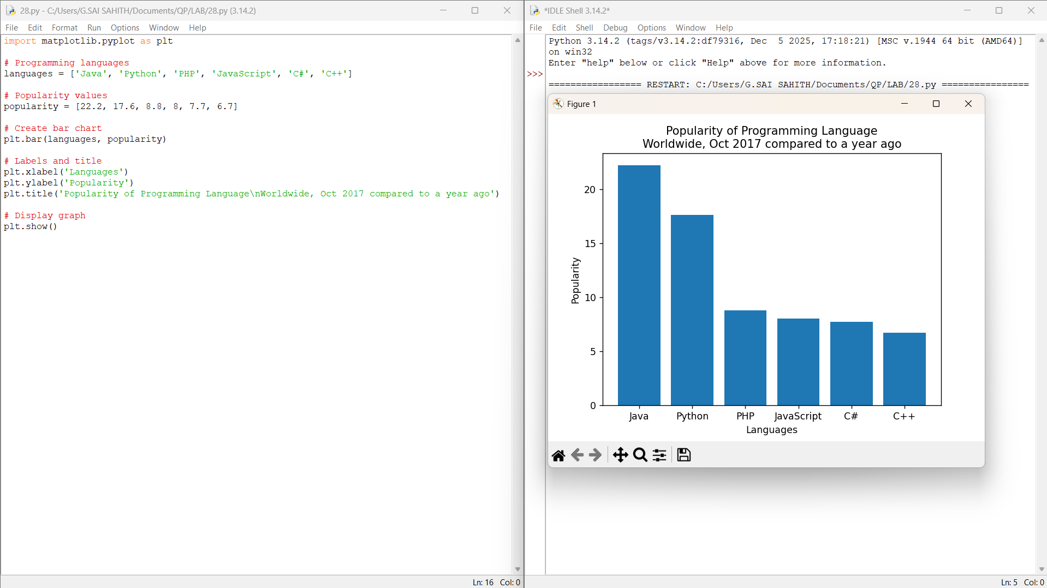

Result:
Thus, the bar chart representing the popularity of different programming languages was successfully displayed using Matplotlib.

DATE: 18-06-2026

EXPERIMRNT-28:

AIM: To write a Python program to display a horizontal bar chart representing the popularity of programming languages using Matplotlib.

ALGORITHAM:
- Import the matplotlib.pyplot module.
- Create a list of programming languages.
- Create a list of popularity values.
- Use the barh() function to create a horizontal bar chart.
- Add labels to the x-axis and y-axis.
- Add a suitable title to the chart.
- Display the chart using show().
- End the program.

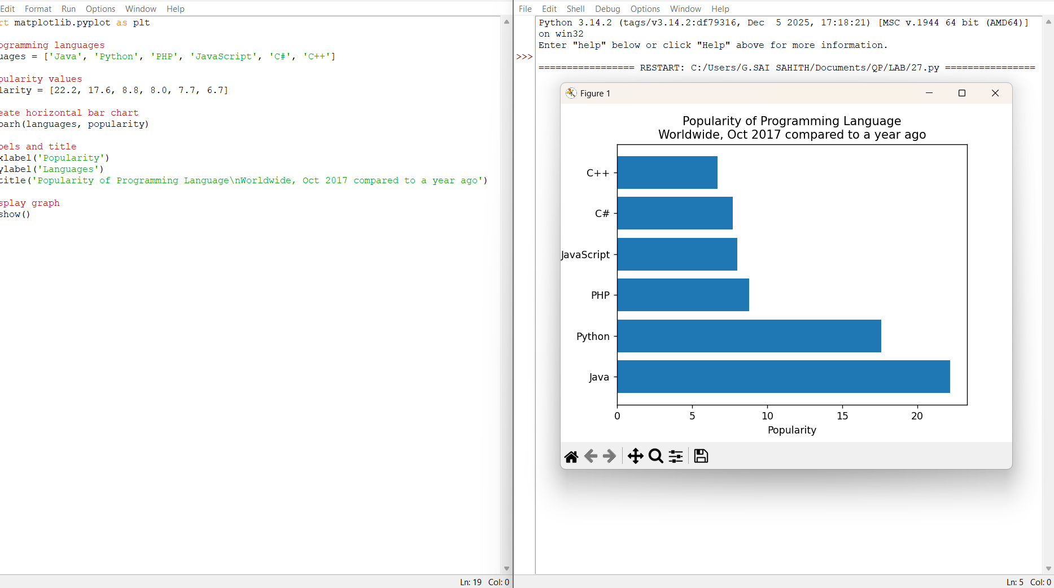

Result:
Thus, the horizontal bar chart representing the popularity of programming languages was successfully displayed using Matplotlib.

DATE: 18-06-2026

EXPERIMRNT-29:

AIM: To write a Python program to display a bar chart of the popularity of programming languages using different colours for each bar.

ALGORITHAM:
- Import the matplotlib.pyplot module.
- Create a list of programming languages.
- Create a list of popularity values.
- Create a list of different colours for each bar.
- Use the bar() function to draw the bar chart with collars.
- Add labels to the x-axis and y-axis.
- Add a suitable title.
- Display the chart using show().
- End the program.

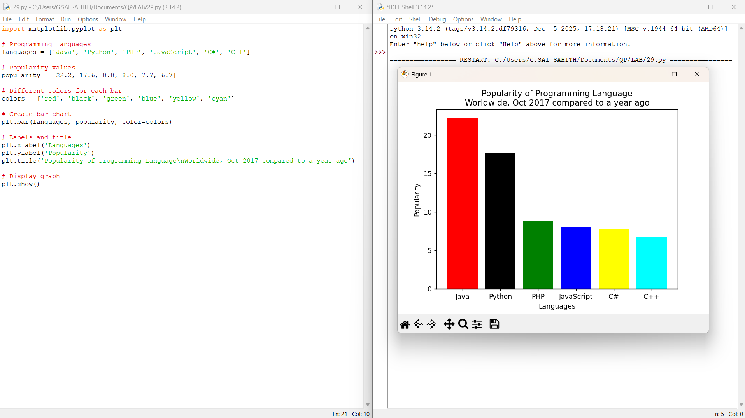

Result:
Thus, the bar chart displaying the popularity of programming languages with different colours for each bar was successfully created using Matplotlib.
DATE: 18-06-2026

EXPERIMRNT-30:

AIM: To write a Python program to create a grouped bar chart showing scores of men and women for different groups using Matplotlib.

ALGORITHAM:
- Import the required libraries (matplotlib.pyplot and NumPy).
- Create lists containing the scores of men and women.
- Create group labels (G1, G2, G3, G4, G5).
- Set the positions of bars using NumPy.
- Plot bars for men and women with different colours.
- Add labels for the x-axis and y-axis.
- Add a title and legend.
- Display the chart using show().
- End the program.

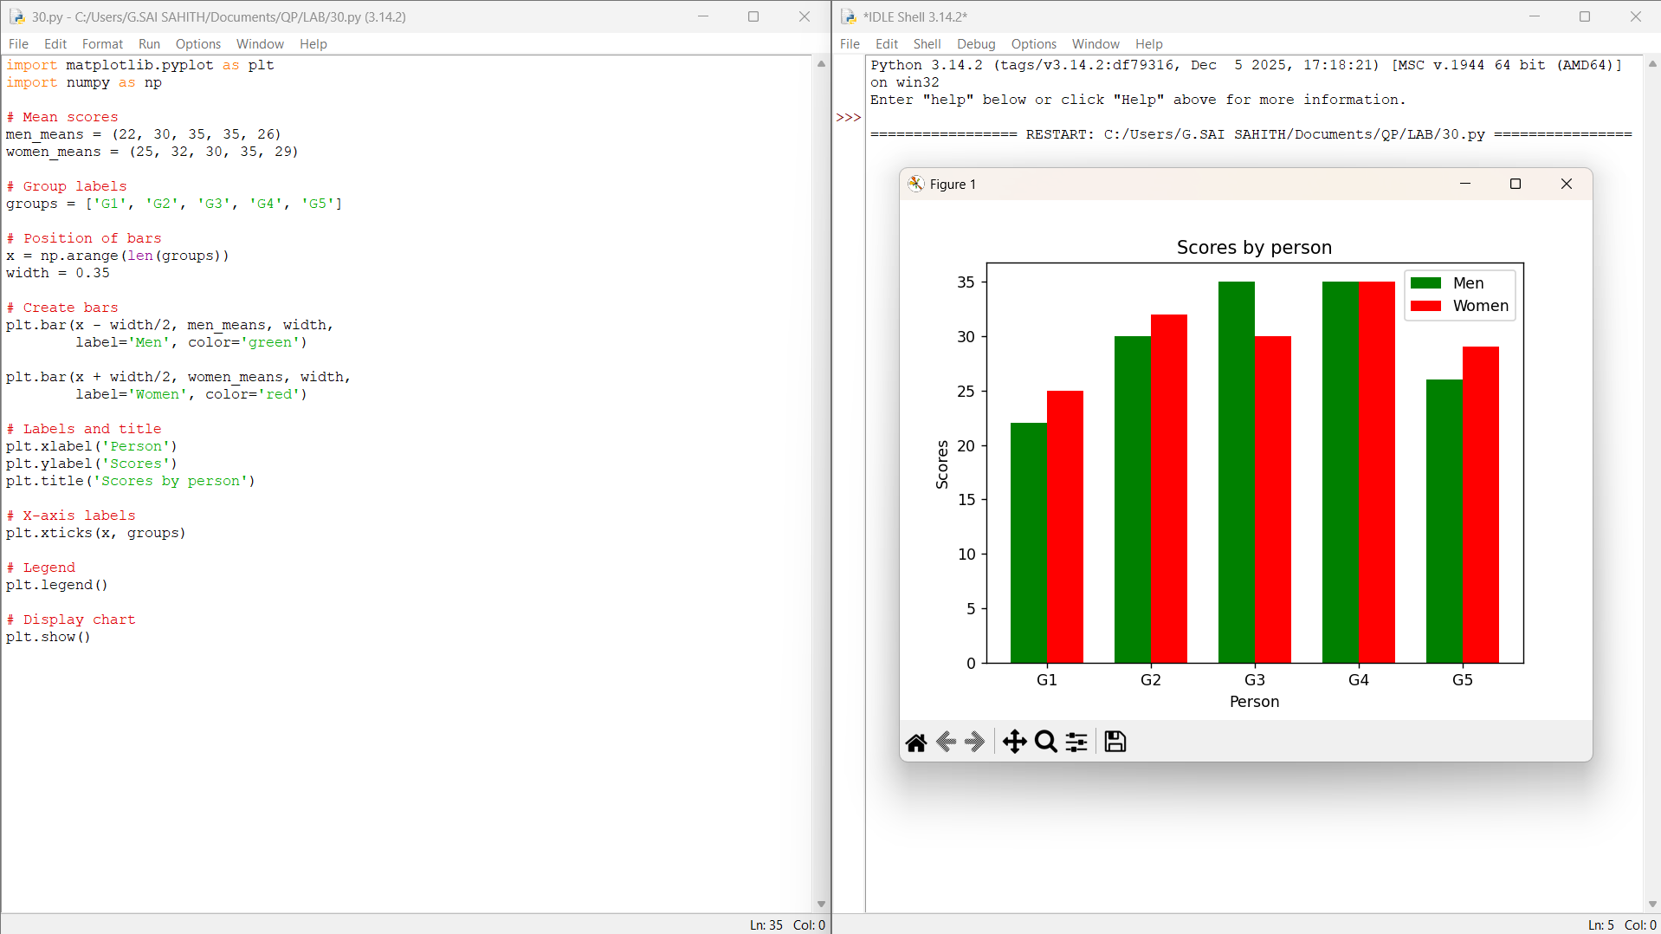

Result:
Thus, the grouped bar chart showing scores by group and gender was successfully created using Matplotlib.

